TP Nº12 – INGLÉS – 4ºA Y 4ºB
HELLO 4TOS! HOW ARE YOU! ¡Espero que bien! En este trabajo seguimos viendo el Tiempo Futuro (going to Future). En este caso veremos cómo son las Preguntas en Futuro.
Look!
Are you going to work next summer holiday? (¿Vas a trabajar las próximas vacaciones de verano?)
Yes, I am. / No, I’m not.
Is she going to study tomorrow? (¿Ella va a estudiar mañana?)
Yes, she is. /No, she isn’t.
What are you going to do next weekend? (¿Qué vas a hacer el fin de semana?)
I’m going to meet my friends. (Voy a ver a mis amigos.)

Para las preguntas de YES/NO comienzo con TO BE (am-is-are) y continuo con la persona + GOING TO +verbo.
O puedo comenzar con una palabra de pregunta (Wh-) y continuar como la pregunta YES/NO.

1)Read the text. (lee el texto). “Summer sport resolutions” (Resoluciones de deportes de verano.)

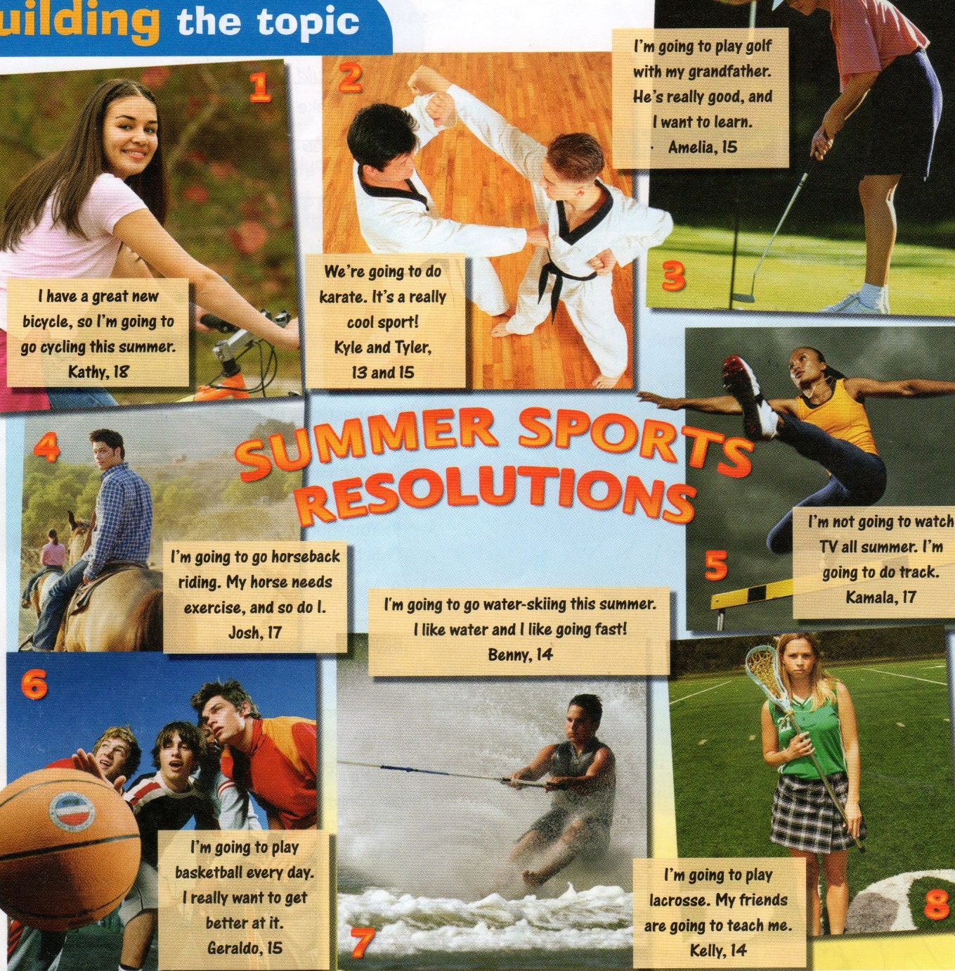
2)Match. (Uní los Números de fotos con el nombre del deporte o actividad de abajo.)
a-do karate ………..
b-do track ………..
c-play golf …………
d-go horseback riding ……….
e-play lacrosse ………..
f-go water-skiing ………..
g-play basketball ………..
h-go cycling …………

3)Write the names. (Escribe el nombre del personaje según los datos. La 1, es un ejemplo)
1-He is going to do a water sport. ……Benny…..
2-She has a new bike. ………………
3-He is going to ride his horse. ……………….
4-They are going to do a martial art. ………………
5-She is not going to watch T.V. ……………………

4)Match (Uní las preguntas con las respuestas.)
1-Is Geraldo going to play basketball? A-She’s going to play golf with her grandfather.
2-What is Amelia going to do? B-No, she isn’t. She’s going to play lacrosse.
3-Is Kelly going to play tennis? C-Yes, he is.

And you? What are you going to do next holiday?(¿Y vos? ¿Qué vas a hacer las próximas vacaciones?)
I’m going to ……………………………………………………………….

¡Espero que puedan resolver los ejercicios!
Sigo recibiendo los TP en mi correo: profesoralilianacancellieri@gmail.com

¡Seguimos con las reuniones de MEET! En el próximo encuentro vamos a comentar cómo era el teatro en la época de Shakespeare, y de Queen Elizabeth I (1558-1603). En el TP anterior les propuse mirar un video; esta vez les incluyo algunos datos de interés que aparecieron en ese video, por las dudas que haya sido difícil de comprender. También adjunté una imagen del Globe Theatre, como se vería en aquellos tiempos:

“The Globe theatre”

-It was located outside the city of London.
-It was made of wood.
-It had a circular shape.
-It was built in 1599 for the company: “The Lord Chamberlain’s Men” (Shakespeare’s company).
-It had a capacity of about 3,000 people.
-A lot of people went to the theatre, because it wasn’t expensive. (It cost 1 penny.)
-The plays attracted people because they were about life and love, human triumphs and human failures. They were comedies, and tragedies.
-It had 3 roofed galleries.
-The people that were standing in the yard in the open air were the “groundlings”. (los que estaban abajo, de pie)
-The stage (escenario) was small, only 12 actors could appear. They were very near the audience.
-There was a trap door (puerta trampa), on the stage, for devilish apparitions or disappearances.
-There was no scenery (decorado). They used simple objects, chairs, tables, swords, and a canvas for the sun or the moon. An actor had a torch to represent the night. There was no artificial light.
-There were no actresses, so young boys acted the parts of women.
-There was an upper stage (escenario más alto) for the musicians.
-There were vendors (vendedores) selling food.
-When a play was in progress there was a flag (bandera) at the top of the roof of the theatre.

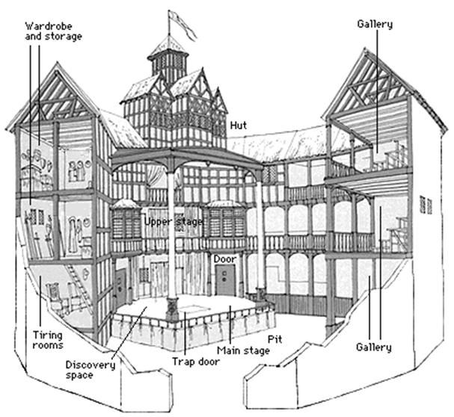

¡Espero que se puedan unir al próximo MEET! Que será:
Fecha: 2/11 -Hora: 17:20 a 18:00
Link de la reunión: https://meet.google.com/qot-dudw-axn

¡Les mando un abrazo grande!
A BIG HUG!
Prof.Liliana

